**cjs**

**P.7 MATHEMATICS 2019**

**Name: ____________________________________________Index No:_____________________**

**SECTION A (40 MARKS)**

1. Workout: 2 x 3
2. Write CDXCVI in words.

1. Given that set k = {a, b, c}. Find the number of subsets in set k.
2. Given that 3y x 32 = 27. Find the value of y.

1. Find the value of y in degrees.

y

800

1. Reduce sh. 12,000 in the ratio of 2:3.

1. Given that 103n = 28ten. Find the value of n.

1. A P.7 orientation session started at 5:00pm and lasted 1 ¼ hrs. At what time did it end?

1. Solve for p; 3(p+3) – 2(p+1) = 10
2. Find the complement of (x+40)0.

1. How many packets of 250 grammes can be got from 2.5 kilogrammes?

1. Calculate the volume of the cylindrical tin below (Take π=)

14cm

10cm

1. The probability that Oketch will go to London next week is . Find the probability that he will not go.
2. Find the first 3 equivalencies of 2(finite 5)
3. Express 0.00463 in scientific notation.

1. Use the figure below to find the value of h.

**C**

24cm

6cm **O**

h

**A D B**

16cm

1. Expand the number shown on the abacus below using place values.

Th H T O

1. On the venn diagram below, describe the unshaded part.

**A B**

1. The median of 3 consecutive even numbers is 14. Find their sum.
2. Multiply +3 x +4 using a number line.

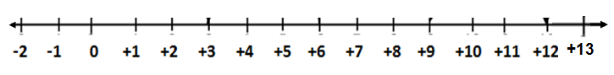

**SECTION B (60 MARKS)**

1. At a party of 80 invited guests, 56 guests were served with sodas (S), y were served with mineral water (M), 7 did not take any of the two drinks and 20 guests were served with both drinks.

a) Represent the above information on the venn diagram . (3marks)

n(∑)=80

∩(S) = 56 ∩(M)=y

___ 20 ___

____

b) How many guests were served mineral water? (2marks)

1. a)Find the number which has been expanded below. (2 marks)

(1x10**4**) + (3x10**2**) + (6 x 10**-1**) + (5 x10**-2**)

b) Workout (8.5 x 54) + (8.5 x 46) using the distributive property. (2marks)

1. The rates at which a bank buys and sells United States dollars and Kenya shillings are given in the table below

|  |  |  |
| --- | --- | --- |
| **Currency** | **Rate at which bank buys** | **Rate at which bank sells** |
| One US$ | Ug.sh 4000 | Ug. Sh. 4200 |
| One Ksh. | Ug .sh. 32 | Ug.sh 34 |

a) If a trader has 300 dollars and 5000 Kenya shillings, how much money in

Uganda shillings can he get from the bank? (2marks)

b) Peter has Ug. Sh 1,176,000, how much in Us dollar can he get from the

bank? (2marks)

1. Akello spends of her salary on food, of the remaider on rent and saved sh. 240,000.

a) What fraction does she save? (3marks)

b) How much does she earn as salary? (2marks)

1. The interior and exterior angle of a regular polygon is in the ratio of 4:1.

a) Find the size of each angle. (3marks)

b) Name the polygon. (2marks)

1. Two bells ring at an interval of 30 min and 40 min respectively to change lessons in Raphela Junior School. If they first rang together at 8:10am,

a) After how long will they ring together? (3marks)

b) At what time will they ring together again? (2marks)

1. Study the figure below. Use it to answer the question that follow

**C**

10cm

h

**A O B**

16cm

1. Find the area of triangle ABC.

1. Calculate the perimeter of the figure.
2. a) Olebo sold a chair at sh. 88,000 making a profit of 10%. At what

price did he buy the chair? (3marks)

b) Calculate his profit.

1. 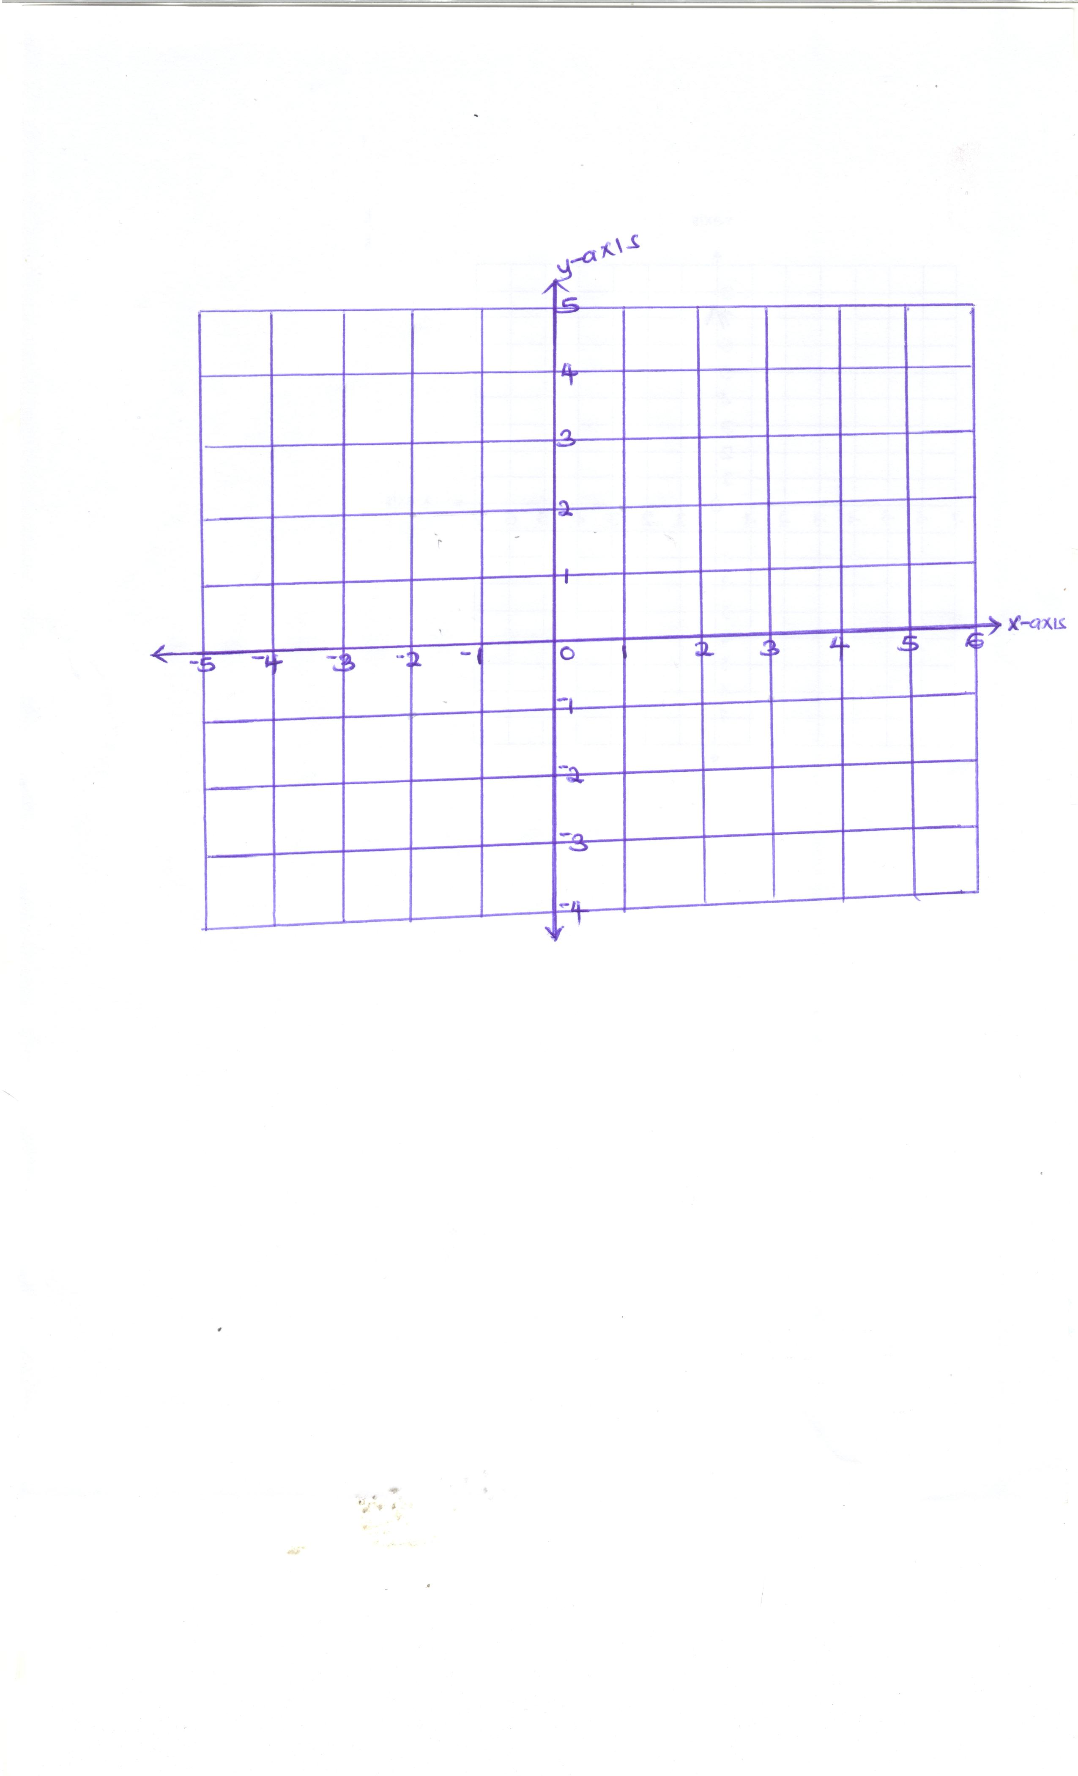

a) Plot the coordinates A(-2, +2), B(+1, +2), C(3, -1)and D(-2, -1) on the Cartesian graph above.

b) Join A to B, B to C, C to D and D to A.

c) Name the plotted geometric figure.

1. a) Adong is 20 years old and his cousin is 5 years old. In how many

years will Adong be twice as old as her cousin? (3marks)

b) Express Adong’s age in 16years time in Roman numerals.

1. a) Simplify:  (3marks)

b) Express 0.2727… as a common fraction in its lowest terms. (2marks)

1. Construct a rhombus PQRS such that diagonal PR = 8cm and

diagonal QS = 6cm. (4marks)

b) Calculate its perimeter (2marks)

**END**